
AMERICAN INTERNATIONAL
UNIVERSITY-BANGLADESH
Faculty of Science and Technology

Choose an item.

Date of Submission: | 16 November 2025
Course Title: | COMPUTER NETWORK
Course Code: | COE3206 |  | Section: | I
Semester: | Fall | 2025-26 | Course Teacher:
  Dr. Rajarshi Roy Chowdhury

Group Name/No.:

No | Name | ID | Program | Signature
1 | Shahriar Adnan Isty | 22-43377-2 | BSc [CSE]
2 | Abu Sifat | 22-48299-3 | BSc [CSE]

LAB-1:

Experiment 1: Direct Connection Between 2 PCs.
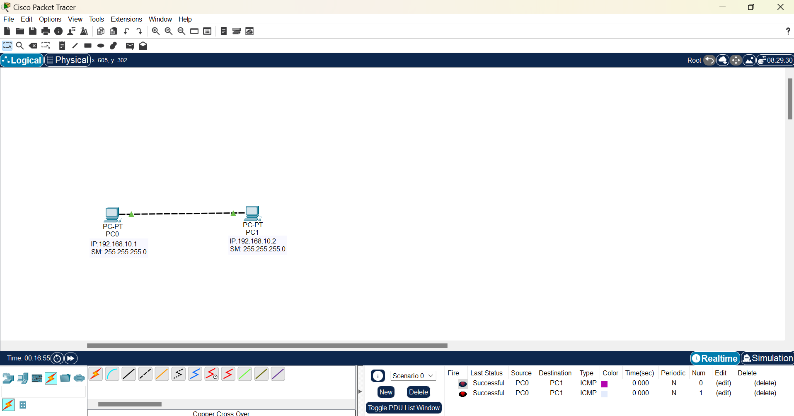

Description:

- Two PCs are configured on the same local network.
- Each computer recognizes the other as a direct neighbor.
- They can communicate and transfer files immediately without additional network devices.
- The IP settings establish a direct peer-to-peer connection.
- Data flows seamlessly between the two devices.
- IP of the PCs are 192.168.10.1 and 192.168.10.2.

Procedure:
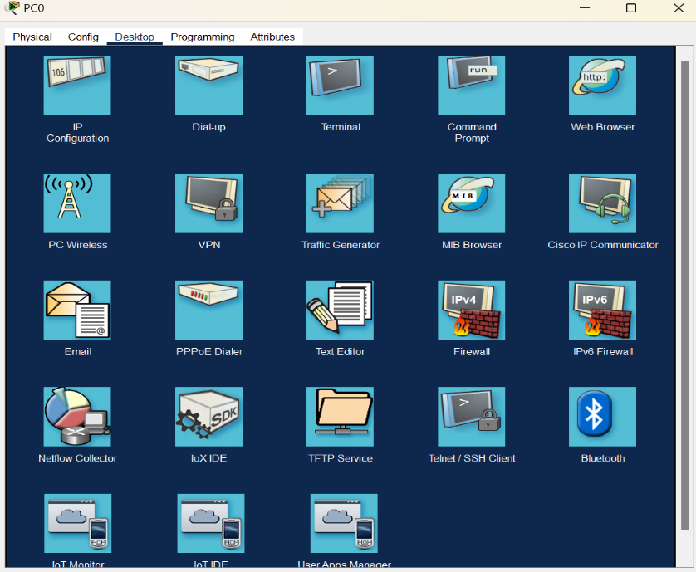

Experiment 2: 3 PCs Connected via one Hub.
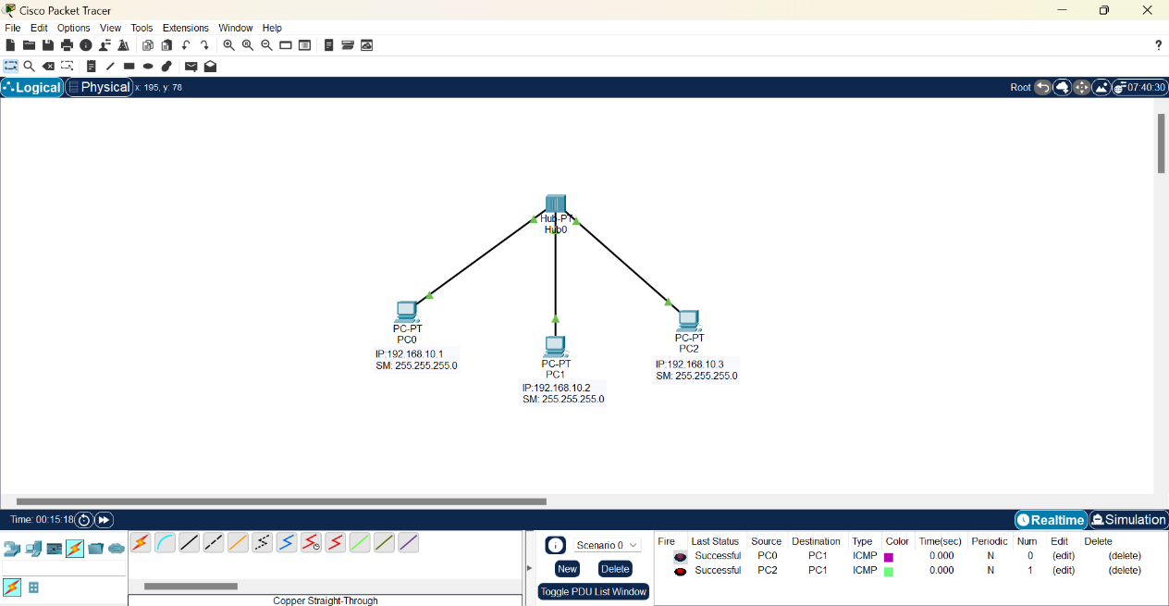

Description:

- Three PCs are configured within the same network subnet.
- A hub is used to physically connect all the PCs.
- Hub is used for connecting multiple PCs.
- The IP settings make them logically part of one shared network segment.
- IP of the PCs are 192.168.10.1, 192.168.10.2 and 192.168.10.3.
- Any PC can communicate with any other PC in the network.
- The hub broadcasts all traffic to every port.

Procedure:

Following experiment 1.

Experiment 3: Two Hubs Connected Together.

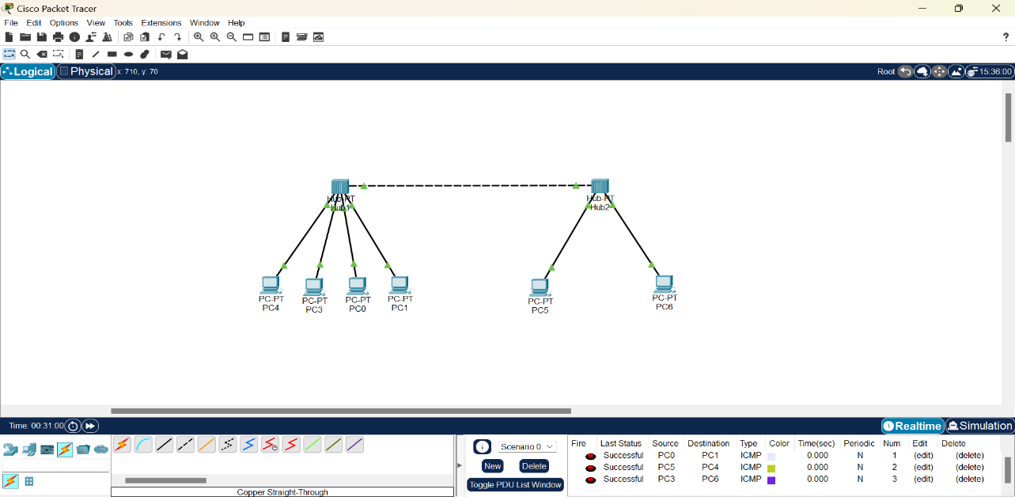

Description:

- Two hubs are connected, each containing multiple computers.
- All devices are configured with the same network settings.
- An extended network is formed, allowing communication between computers on different hubs.
- File transfers between computers on separate hubs work the same as those on the same hub.
- The experiment demonstrates how network devices extend connectivity across multiple segments.
- A unified network environment is maintained throughout the setup.
- IP of the PCs are 192.168.10.1, 192.168.10.2, 192.168.10.3, 192.168.10.4, 192.168.10.5 and 192.168.10.6.

Procedure:

Following experiment 1.

LAB-2:

Experiment-1: Connecting two Switch network via one Bridge.

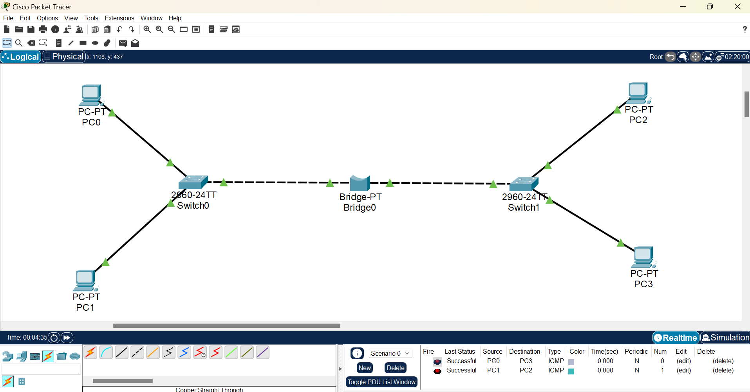

Description:

- Two separate switch networks are connected using a single bridge.
- Each switch manages multiple connected devices within its own local network.
- The bridge serves as an intelligent device that links the two switches while managing traffic between them.
- It filters and forwards data based on MAC addresses, reducing unnecessary network congestion.
- Devices on both switches can communicate as if they are part of one extended network.
- This setup improves network efficiency and segmentation compared to using hubs.
- IP of left Switch network PCs are 192.168.1.1 and 192.168.1.2.
- IP of right Switch network PCs are 192.168.1.3 and 192.168.1.4.

Procedure:

Following experiment 1.

Experiment-2: Connecting two Switch network via one Router.

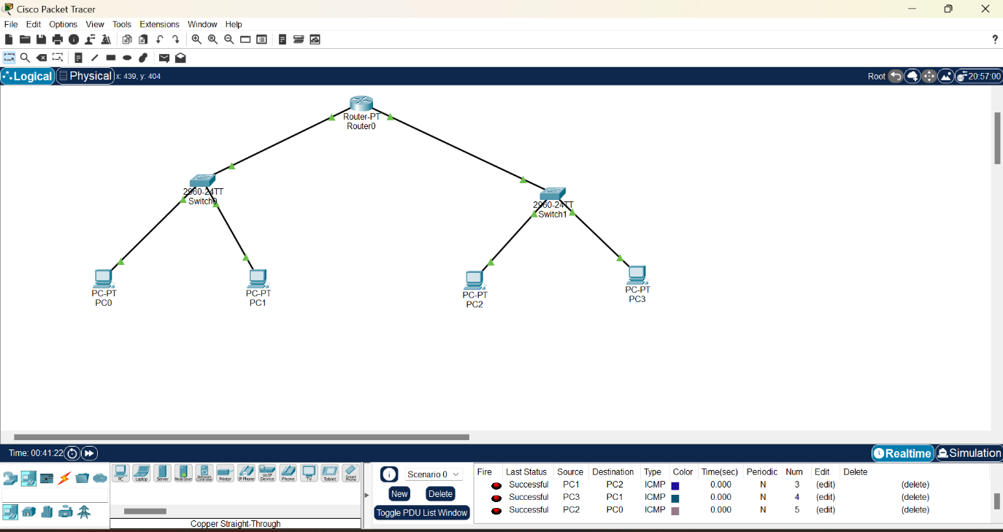

Description:

- Two switch networks are connected through a single router.
- The router has two interfaces: f0/0 (192.168.10.1) and f0/1 (192.168.11.1).
- The left switch network uses 192.168.10.1 as its default gateway.
- The right switch network uses 192.168.11.1 as its default gateway.
- Each switch network operates within its own subnet: 192.168.10.0 and 192.168.11.0.
- The router enables communication between the two subnets through inter-network routing.
- Devices from one switch network can exchange data with devices on the other network via the router.
- This setup demonstrates how a router connects and manages traffic between multiple subnets.
- IP of left Switch network PCs are 192.168.10.2 and 192.168.10.3.
- IP of right Switch network PCs are 192.168.11.2 and 192.168.11.3.

Procedure:

Following experiment 1.

Procedure:
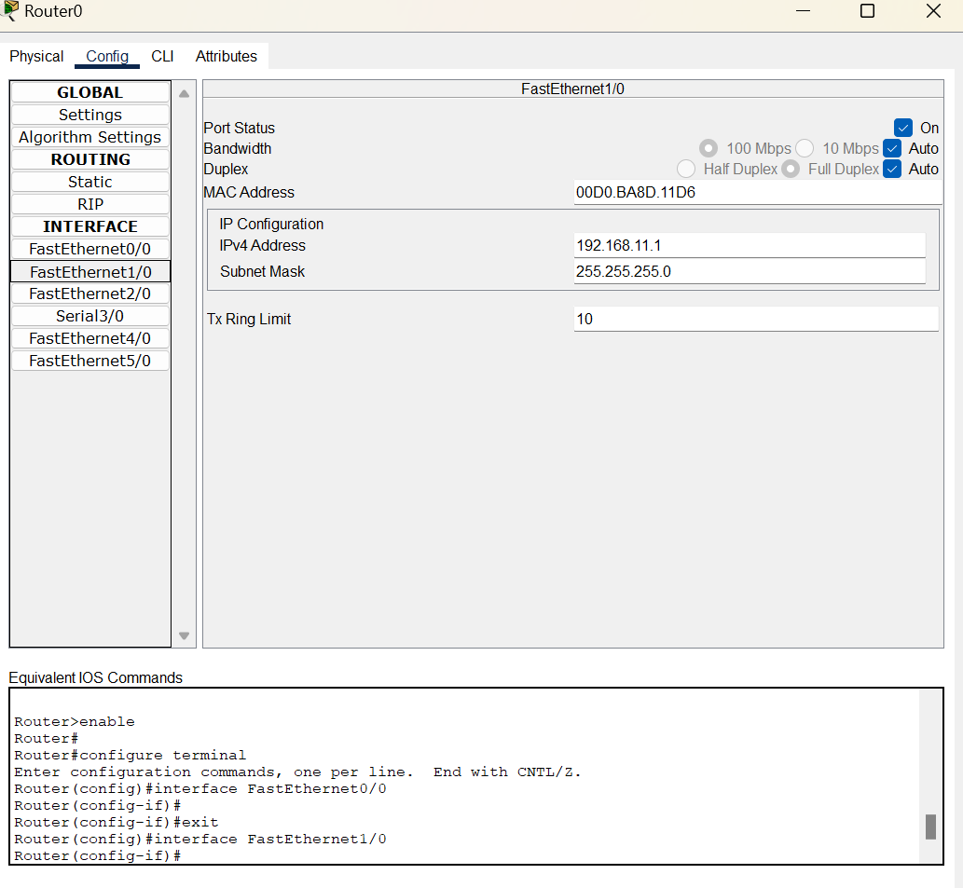
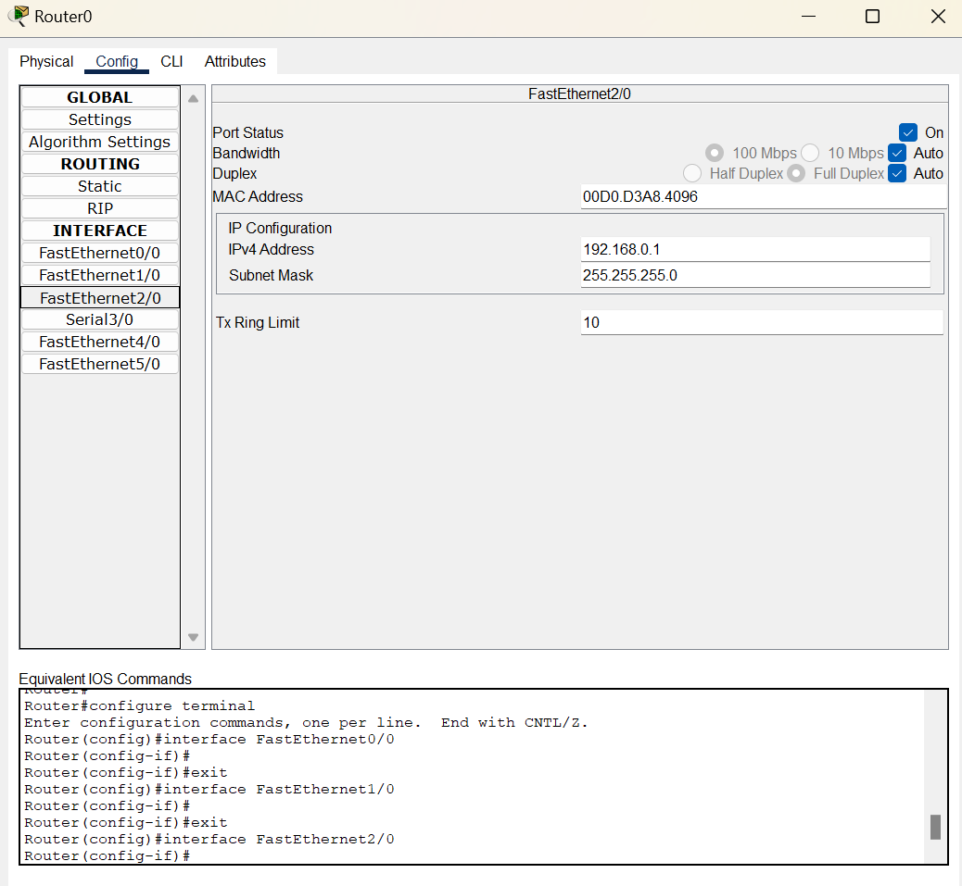

LAB-3:

Experiment-1: Connecting two Switch network via one Router and the left Switch connection has a DHCP Server and both Dynamic and static connection.
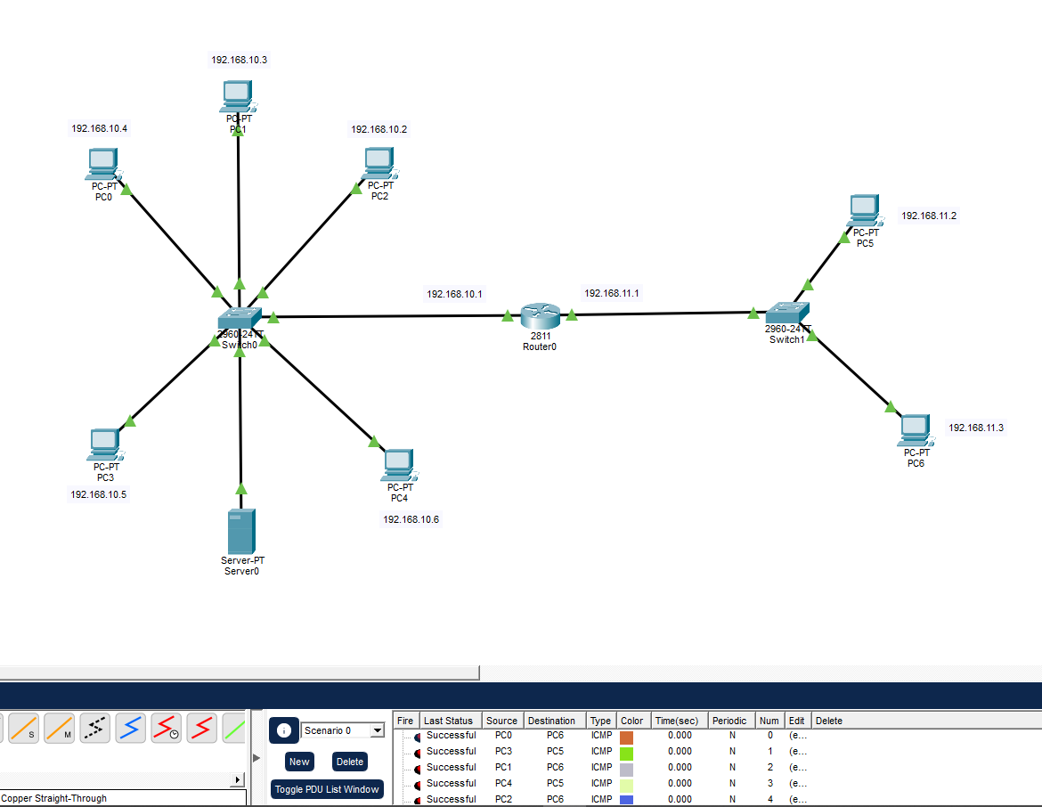

Description:

- Two switch networks are connected through a single router.
- The router has two interfaces: f0/0 (192.168.10.1) and f0/1 (192.168.11.1).
- The left switch network uses 192.168.10.1 as its default gateway.
- The right switch network uses 192.168.11.1 as its default gateway.
- Each switch network operates within its own subnet: 192.168.10.0 and 192.168.11.0.
- The left switch network includes a DHCP server that automatically assigns IP addresses to devices.
- The IP address of DHCP Server is 192.168.10.2 and default gateway 192.168.10.1.
- Devices on the left switch can connect using either dynamic (DHCP) or static IP configurations.
- The right switch network connects to the router on a separate subnet and uses the router as its default gateway.
- The router provides inter-network communication between the two switch networks.
- This setup demonstrates how DHCP and static addressing can coexist in a routed multi-switch network.

Procedure:
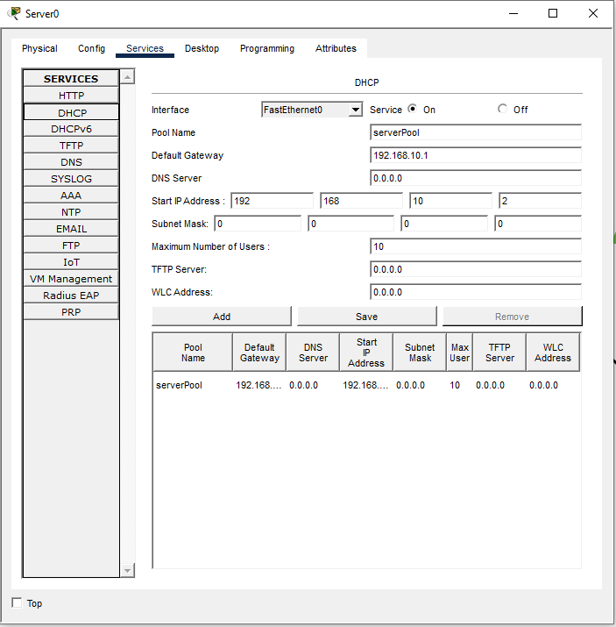

Experiment-2: Connecting multiple PCs with the WIFI Router with both wired and wireless.
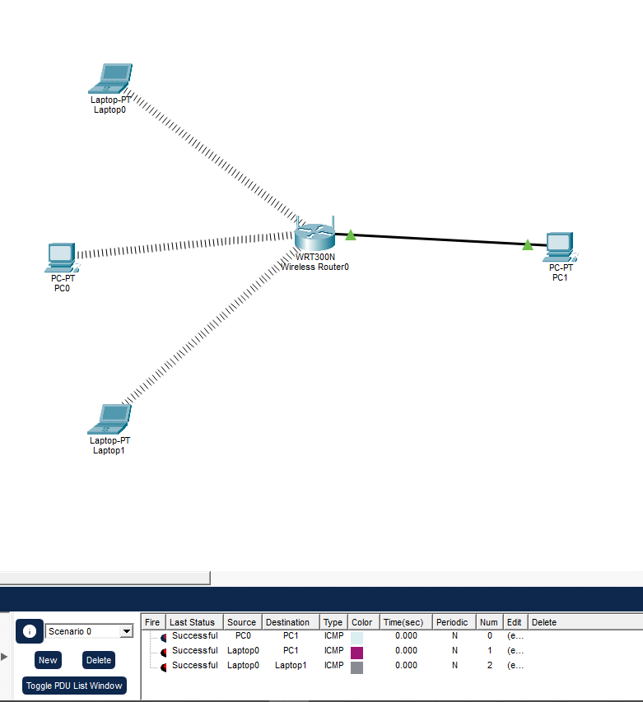

Description:

- Multiple PCs are connected to a Wi-Fi router using both wired (Ethernet) and wireless (Wi-Fi) connections.
- Wired PCs are connected through the router’s LAN ports using Ethernet cables.
- Wireless PCs connect via the router’s Wi-Fi network using the same network credentials.
- The Router is set up by GUI configuration, the name of the network and password is set up with WEP.
- The PCs must have WIFI dongle connected for wireless connection.
- All devices share the same IP subnet managed by the router’s DHCP server, which automatically assigns IP addresses.
- Both wired and wireless PCs can communicate, share files, and access the internet seamlessly.
- The setup demonstrates how a Wi-Fi router integrates wired and wireless connections into a single local network.
- It also shows how the router acts as a central point for network management and internet access.

Procedure:
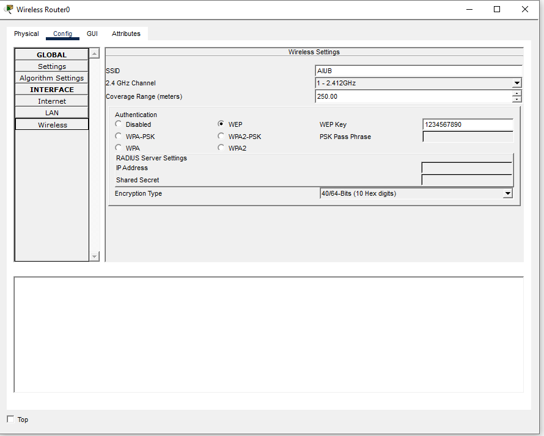

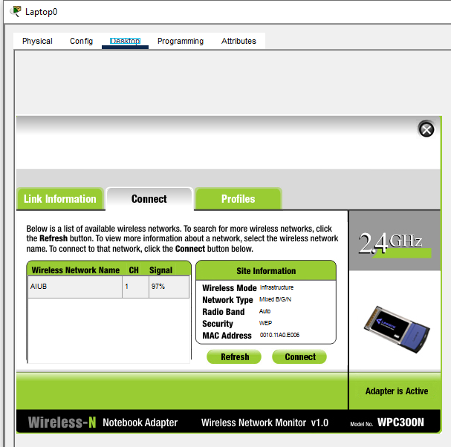

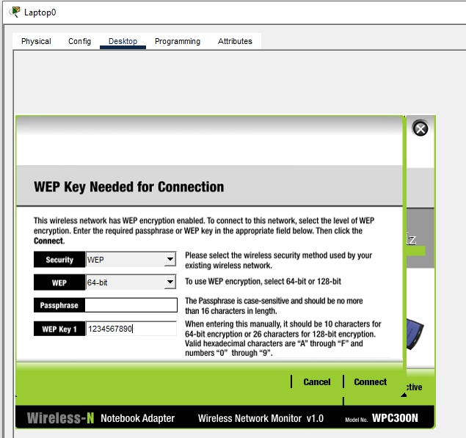

Experiment-3: Connecting two Routers with each Other the Routers are individually connected with other PC connection and Switch Network.
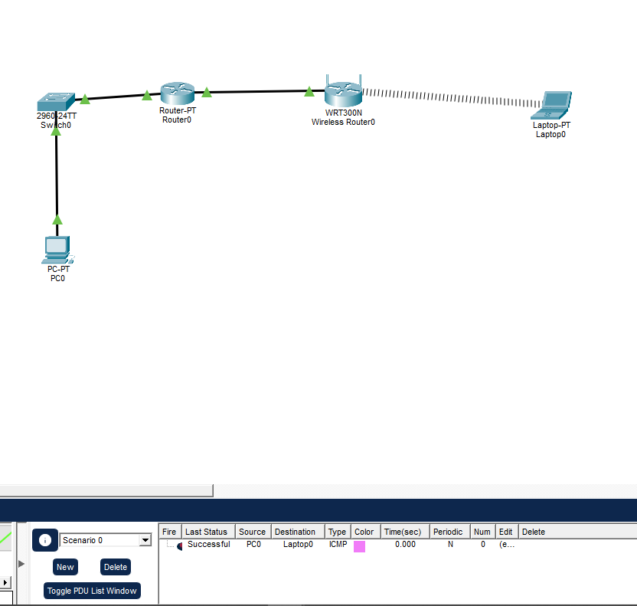

Description:

- Two routers are connected directly to each other to form an extended network.
- Each router manages its own local network, including connected PCs and switch networks.
- The first router ethernet f1/0 port connects to a group of PCs and switches on default gateway 192.168.1.1.
- The WIFI Router Internet is configured as static and default gateway 192.168.0.2.
- The WIFI Router connects to another set of PCs on default gateway 192.168.0.2.
- The routers are connected via their interfaces (e.g., Router1 f0/0 ↔ Router2 f0/0) with appropriate IP configuration.
- Static routes or dynamic routing protocols are used to enable communication between the two networks.
- PCs from one router’s network can communicate and share data with PCs from the other network through the router-to-router link.
- This setup demonstrates inter-network communication between two independent networks using routers as gateways.

Procedure:

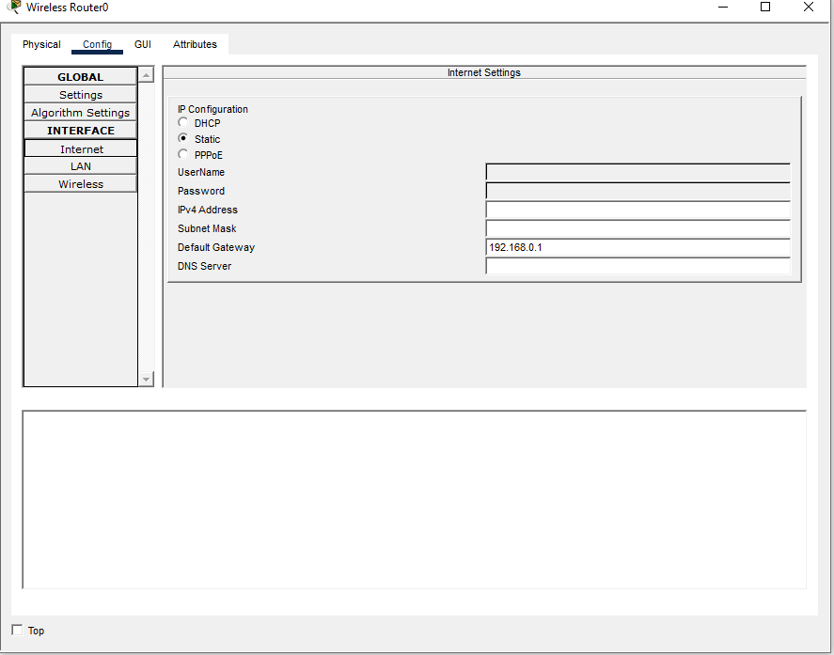

LAB-4:

Experiment-1: Connecting three Router (two pt routers and one WIFI router) and Routers are connected through static Routing and establishes connection with each other PC, all the router has complex networks that consists Bridge, Hubs and Switches and DHCP server and the network has both static and dynamic connection.
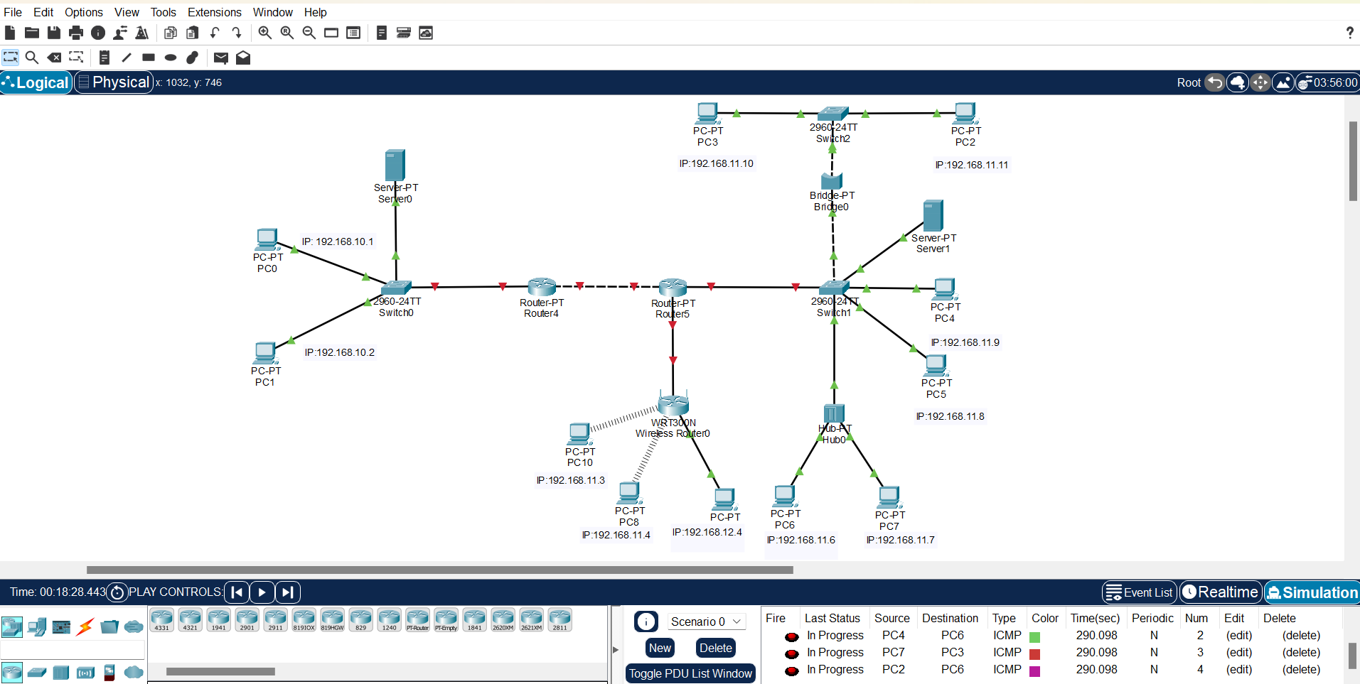
Description:

- Three routers are connected together two PT routers and one Wi-Fi router using static routing.
- Each router manages its own complex local network consisting of bridges, hubs, and switches, which include multiple PCs.
- The first PT router has default gateway 192.168.1.1, the second PT router has default gateway 192.168.2.1, and the Wi-Fi router has internet network 192.168.0.2.
- Each PT router uses an additional Ethernet port to connect to the other router and to its own network.
- The routers are linked through their interfaces: Router1 f0/0 ↔ Router2 f0/0, Router2 f0/1 ↔ Wi-Fi Router f0/0.
- Router1 has IP address 192.167.3.2 on f0/0, Router2 has IP addresses 192.167.3.3 on f0/0 and 192.167.5.2 on f0/1, and Wi-Fi Router has IP 192.167.5.3 on f0/0.
- Static routes are manually configured on all three routers to define paths to each other’s networks.
- On Router1, static connection: Network IP-192.168.2.0, Subnet Mask-255.255.255.0, Next Hop IP-192.167.4.3.
- On Router2, static connections: Network IP-192.168.1.0, Subnet Mask-255.255.255.0, Next Hop IP-192.167.4.2 and Network IP-192.168.3.0, Subnet Mask-255.255.255.0, Next Hop IP-192.167.5.3.
- On Wi-Fi Router, static connection: Network IP-192.168.2.0, Subnet Mask-255.255.255.0, Next Hop IP-192.167.5.2.
- PCs connected to any router’s network (via switch, hub, or Wi-Fi) can communicate and exchange data across all three networks.
- The setup demonstrates how static routing can connect multiple complex LANs, supporting both static and dynamic IP addressing.
- It highlights the integration of routers, bridges, hubs, switches, and DHCP servers to maintain a unified hybrid network.

Procedure:
